  - Micro Frontend Architecture with AEM and Microservices
  - AEM and Microservices Through Micro-Frontends for Cohesive User Experiences

  - Date:08/03/2023
  - Authors: Kalimuthu Aruchamy, Bhupesh Pipley, Subash Selvaraj.

Table of contents
1 Introduction 4
1.1 Overview of the whitepaper 4
1.2 Purpose and objectives of the Micro Frontend Architecture 4
2 Understanding Micro Frontend Architecture 4
2.1 Definition of Micro Frontends 4
2.2 Advantages of Micro Frontend Architecture 4
2.3 Key principles and components of Micro Frontend Architecture 5
2.4 How Micro Frontends overcome challenges faced by monolithic architectures 5
3 Leveraging AEM as a Content Provider 6
3.1 Introduction to Adobe Experience Manager 6
3.2 Benefits of using AEM for content management in MF Architecture 6
4 Business Case 6
4.1 Problem Statement 6
4.2 Proposed Solution 7
4.3 Benefits of the Proposed Solution 7
5 Solution and Architecture 7
5.1 Design System (Reusable React Components Library) 7
5.2 Micro Frontends (MFs) and Akamai CDN 7
5.3 AEM's as Container Application 8
5.4 GraphQL Integration for Content Access 8
5.5 Microservices for Core Business Data 8
5.6 Sequence Diagram 8
5.7 Architectural Benefits 9
6 Implementation 10
6.1 AEM Content As a Service Strategy 10
6.2 Code Repo Setup 10
6.3 Scope for Optimization 10
7 Future Considerations 11
7.1 Micro Frontend s in Headless AEM 11
7.2 AEM GraphQL vs. AEM Content Services 12
7.3 BFF 12
8 Conclusions 13
9 Resources 14

Introduction

Overview of the whitepaper
This whitepaper aims to outline the implementation of a Micro Frontend Architecture by combining Adobe Experience Manager (AEM) as a content provider and External Microservices for business data. By adopting this modern architectural approach, content, functionality, and business data are decoupled from each other. Reusability and maintainability are enhanced.

Purpose and objectives of the Micro Frontend Architecture
The primary purpose of implementing a Micro Frontend Architecture is to create a modular, flexible, and scalable application that allows independent development and deployment of frontend components. The objectives include reducing development time, improving user experience through personalized content, and streamlining the management of content and business data.

Understanding Micro Frontend Architecture

Definition of Micro Frontends
Micro Frontends is an architectural approach that involves breaking down a monolithic frontend into smaller, independently deployable units, each responsible for a specific part of the user interface. These units work together to create a seamless user experience, allowing teams to work autonomously and adopt different technologies when necessary.

Advantages of Micro Frontend Architecture
- Scalability: Microservices allow independent scaling of individual services, optimizing resource allocation based on demand, ensuring efficient utilization of hardware and cloud infrastructure.

- Flexibility: Micro Frontend architecture empowers teams to work independently, enabling faster iterations and deployments without affecting the entire application.

- Personalization: AEM's content management capabilities combined with Micro Frontend s allow for personalized user experiences, tailoring content and features to individual users.

- Faster Development: Microservices enable parallel development, reducing dependencies and bottlenecks, leading to faster time-to-market for new features and updates.

- Enhanced User Experience: Micro Frontend s enable a smoother user experience by isolating failures to specific parts of the application, reducing downtime and improving overall user satisfaction.

- Modularity: Microservices encourage a modular approach to development, making it easier to replace, update, or add new functionalities without disrupting the entire system.

- Future-proofing: Adopting headless AEM and Micro Frontend architecture ensures the system's adaptability to emerging technologies and new digital touchpoints.
- Improved Performance: Web workers and caching strategies optimize performance, delivering content faster and reducing latency for a better user experience.

- Decoupled Deployments: Independent deployments of Micro Frontend s and Microservices minimize the risk of system-wide failures, making rollbacks and updates more manageable.

- Easier Maintenance: Microservices' separation of concerns allows for easier debugging, monitoring, and maintenance of individual services, promoting a robust and resilient system.

- Cost Efficiency: Microservices' granular scaling and resource allocation contribute to cost optimization, as resources are allocated based on specific service requirements.

- Agility and Innovation: AEM's headless approach and Micro Frontend architecture foster innovation, allowing teams to experiment and iterate quickly, adapting to changing market demands.

- Cross-Team Collaboration: Microservices encourage cross-functional teams to focus on specialized areas, fostering collaboration and knowledge-sharing for better outcomes.

- Service Reusability: Microservices promote the reuse of functionalities across multiple applications, reducing redundant development efforts and enhancing development efficiency.

- Cloud-Native Adoption: Microservices are well-suited for cloud-native architectures, taking full advantage of cloud scalability, resilience, and auto-scaling capabilities.

Key principles and components of Micro Frontend Architecture
- Decentralization: Breaking the frontend into small, manageable units.
- Isolation: Ensuring components operate independently without interfering with each other.
- Integration: Establishing seamless communication between components.
- Reusability: Promoting code reusability and sharing between teams.

How Micro Frontends overcome challenges faced by monolithic architectures.
Micro Frontend Architecture addresses the limitations of monolithic architectures, such as monolithic codebase, longer development cycles, and difficulty in scaling. It enables a more agile development approach, promotes team autonomy, and fosters continuous deployment, resulting in improved customer experience.
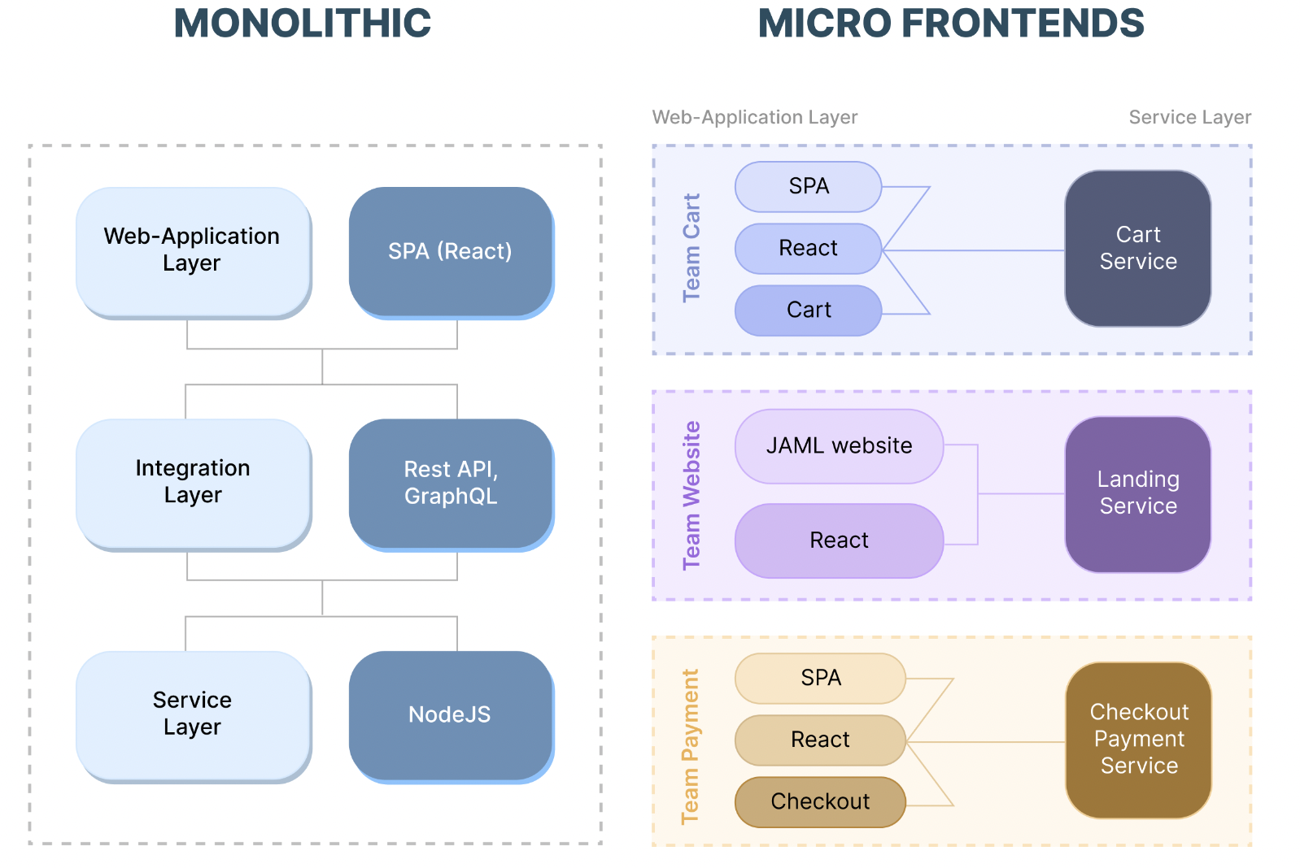
Source: https://www.mindinventory.com/blog/micro-frontend-architecture/

Leveraging AEM as a Content Provider

Introduction to Adobe Experience Manager
Adobe Experience Manager (AEM) is a robust content management solution that empowers organizations to create, manage, and deliver content across various channels. It provides tools for content creation, workflow management, and content personalization.

Benefits of using AEM for content management in MF Architecture
Content Personalization: AEM's powerful personalization capabilities enable to deliver targeted content to customers based on their preferences and behavior.
Content Versioning: AEM's versioning system ensures that content changes can be tracked, rolled back, and reviewed efficiently.
Multichannel Delivery: AEM enables content to be delivered seamlessly across web, mobile, email, and other channels, ensuring a consistent user experience.
Real-time Content Updates: content updates are reflected in real-time on the user interface.

Business Case

Problem Statement
Large scale applications with Frontend monolithic architecture poses challenges in content management, adaptability to market demands, and deployment efficiency. This whitepaper expands a solution that allows for dynamic content updates, scalability, and easy integration with third-party vendors and channels.

Proposed Solution
To address the challenges faced by the existing online booking portal, the proposed solution is to implement a Micro Frontend Architecture, utilizing Adobe Experience Manager (AEM) as a content provider and Microservices for core business data. The Micro Frontend Architecture ensures that the UI remains completely decoupled from business logic and data, enabling independent development and deployment.

Benefits of the Proposed Solution
- Dynamic Content Management with AEM: Utilizing AEM as a content provider allows to manage labels, images, banners, and offer images in real-time without the need for redeployment. This enables personalized content delivery to customers.
- Scalability and Reusability with Micro Frontends: The adoption of Micro Frontends promotes reusability of components, such as booking widgets, across multiple pages and channels, including third-party vendor sites and kiosks. This scalability ensures a consistent user experience across various platforms.
- Faster Development and Deployment: Independent development of Micro Frontends enables faster development cycles, and updates to one Micro Frontend do not require redeployment of the entire system, streamlining the release process.
- Enhanced User Experience: The integration of AEM with Micro Frontends ensures a personalized customer experience, leading to improved satisfaction and loyalty.
- Third-Party Integration: The Micro Frontend architecture facilitates seamless integration with third-party vendor sites, enabling partnerships and expanding the booking portal's reach.

Solution and Architecture
The solution architecture is designed to achieve modularity, reusability, and efficient content management. It revolves around a Micro Frontend Architecture, utilizing a Design System for reusable React components, Akamai CDN for hosting Micro Frontends, and AEM as the container application. The architecture ensures seamless integration between AEM for content management, Microservices for core business data, and Micro Frontends for rendering the user interface.

Design System (Reusable Component Library)
The Design System forms the foundation of the solution, offering a library of reusable React components. By adopting a storybook implementation, the Design System provides numerous benefits like documentation, component previews, and interactive exploration. This empowers development teams to create and maintain a consistent user interface throughout the application.

Micro Frontends (MFs) and Akamai CDN
The Micro Frontend Architecture ensures a modular approach to application development. Each Micro Frontend is an independent, self-contained unit that can be developed, tested, and deployed separately. These Micro Frontends are hosted in the Akamai CDN, enabling efficient content delivery, and minimizing latency for users across the globe.

AEM as Container Application
AEM owns the presentation layer (the “glass”) and acts as the container application that orchestrates the Micro Frontends. It provides the necessary infrastructure for mounting and initializing the Micro Frontends, offering a seamless user experience by stitching the Micro Frontends together into a cohesive application.

GraphQL Integration for Content Access
To access content from AEM, the Micro Frontends utilize GraphQL, enabling efficient querying and retrieval of content. GraphQL serves as an efficient middleware, facilitating content fetching from AEM's backend, reducing over-fetching of data and optimizing the user experience.

Microservices for Core Business Data
To access content from AEM, the Micro Frontends utilize GraphQL, enabling efficient querying and retrieval of content. GraphQL serves as an efficient middleware, facilitating content fetching from AEM's backend, reducing over-fetching of data, and optimizing the user experience.

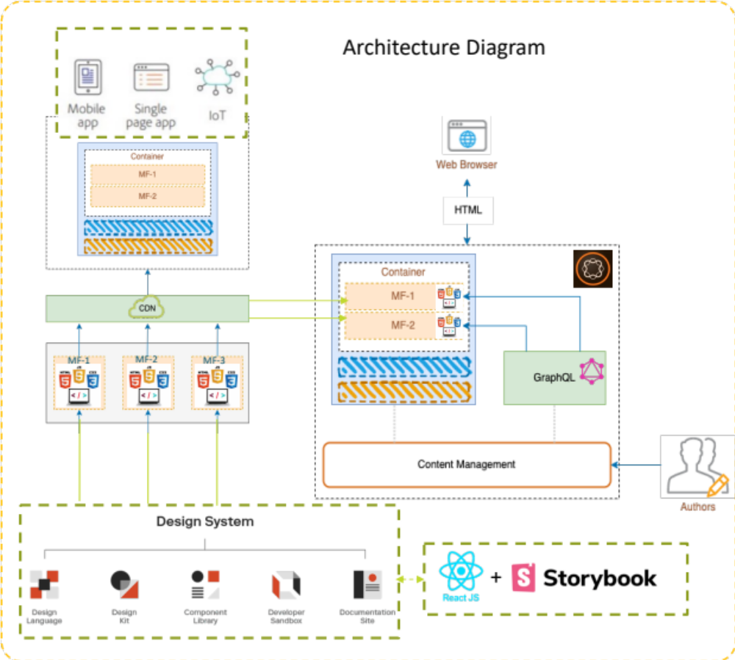

Sequence Diagram
- The user interacts with the AEM container Application, which acts as the entry point to the application.
- The AEM container Application coordinates the Micro Frontends and renders the placeholders/components that will initialize each Micro Frontend.
- Each Micro Frontend accesses content from AEM using GraphQL, allowing for precise data retrieval based on specific requirements.
- Simultaneously, the Micro Frontends interact with Microservices to obtain core business data.
- The Micro Frontends combine data from AEM and Microservices to render the user interface, ensuring seamless data integration and an enhanced user experience.

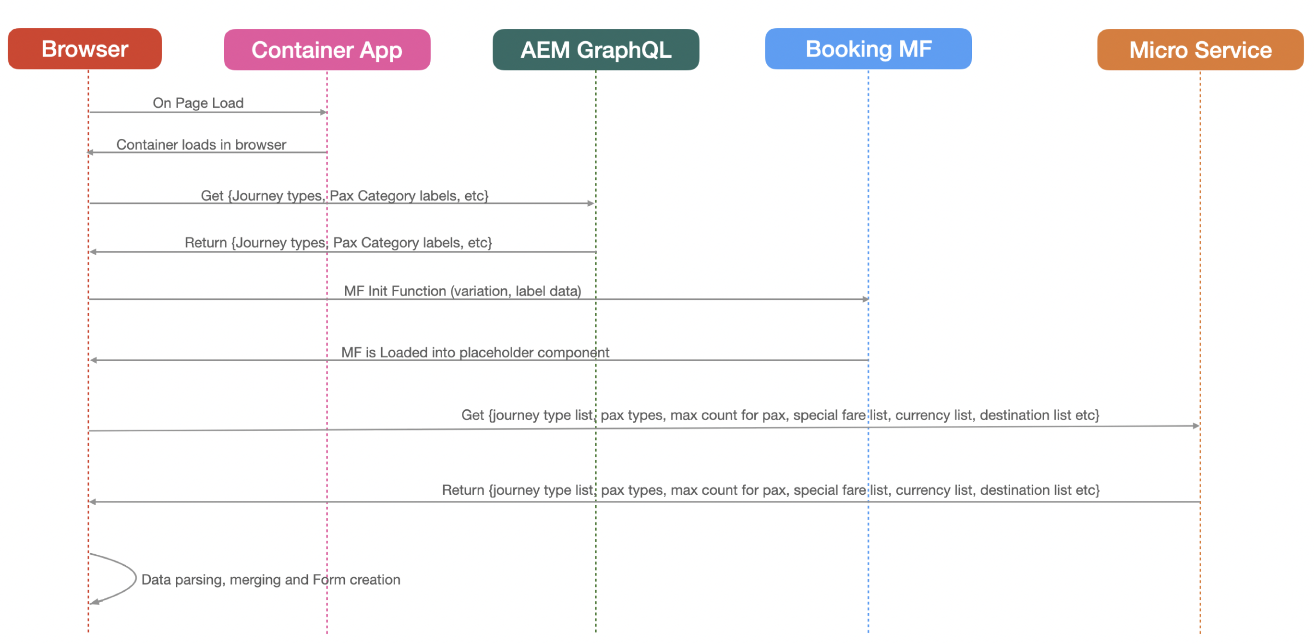

Architectural Benefits
Modularity and Reusability: The Micro Frontend Architecture promotes component reusability and autonomy, allowing teams to work independently on different parts of the application.
Efficient Content Management: AEM serves as a powerful content management system, enabling easy content updates and personalization without the need for redeployment.
Optimized Performance: The use of Akamai CDN ensures fast and reliable content delivery to users, reducing latency and improving the application's performance.
Scalability: The decoupled architecture facilitates horizontal scaling, allowing the system to handle increasing user traffic effectively.
In summary, the proposed solution architecture optimizes the user experience, simplifies content management, and ensures seamless integration of content and core business data through a Micro Frontend Architecture, Design System, and the efficient use of AEM and Microservices

Implementation

AEM Content as a Service Strategy
Content Fragments have been successfully implemented to describe and manage structured content containing various content types, such as text, numerical data, Boolean, date and time, among others. These fragments primarily comprise editorial content, accompanied by related images. It is important to note that Content Fragments are purely focused on content, devoid of any design or layout elements. These fragments are efficiently stored as assets within the existing system.

Code Repo Setup
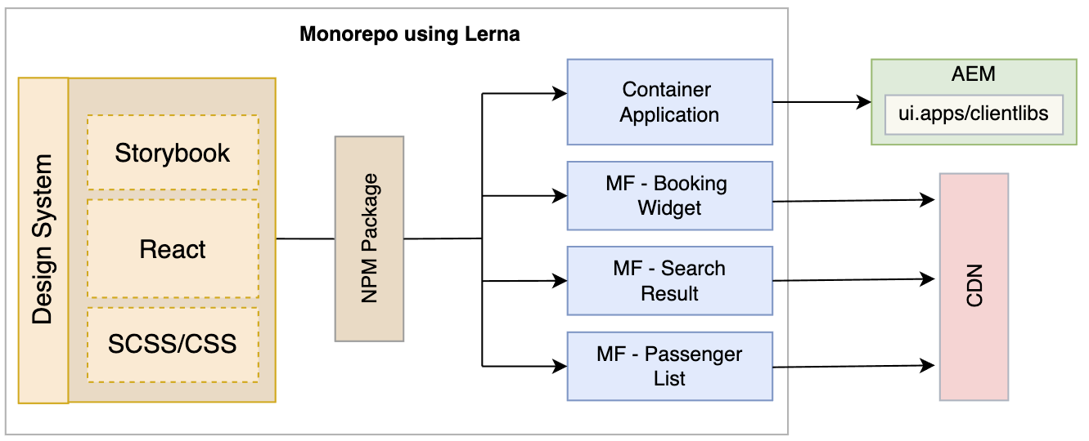

All Micro Frontends and the Design System are organized within a monorepo setup, simplifying version control and facilitating collaborative development.
Lerna, a popular tool for managing JavaScript projects with multiple packages, is utilized to bootstrap all Micro Frontend and Design System packages, ensuring smooth interdependency management.
The Design System, containing reusable components, is treated as a node package and easily integrated into the Micro Frontends through Lerna's capabilities.
Clientlibs, generated through the AEM (Adobe Experience Manager) container application, are responsible for delivering content and presentation to the end-users.

Scope for Optimization
Webworkers:
As web applications grow in complexity, there's an increasing need to optimize performance and responsiveness for a seamless user experience. Web workers offer a promising solution to address this challenge. Web workers allow us to execute computationally intensive tasks in the background, separate from the main UI thread, thus preventing UI slowdowns and unresponsiveness caused by heavy processing. By leveraging web workers, we can offload complex or time-consuming operations, such as image processing, data parsing, or complex calculations, to separate threads. This keeps the main UI thread free to handle user interactions and ensures a smooth and fluid user experience, especially on devices with limited resources.
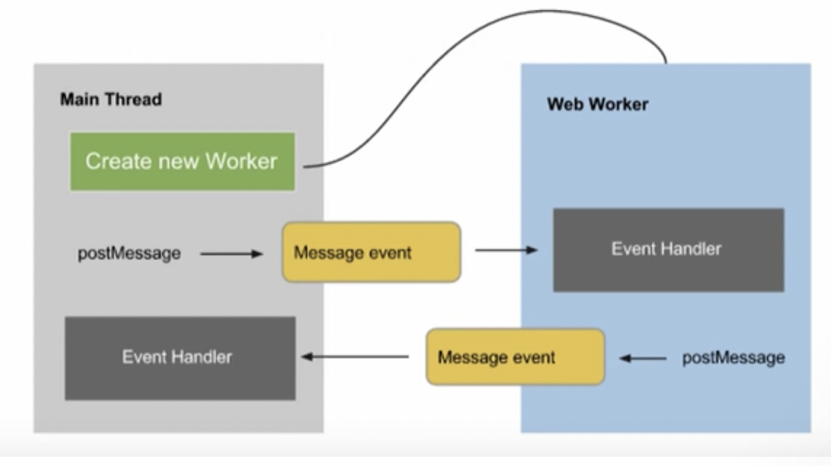
Source: https://jscrambler.com/blog/web-workers-and-the-threads-that-bind-us

Future Considerations

Micro Frontends in Headless AEM
A headless CMS, like AEM, decouples the backend (content management) from the frontend (presentation layer). This approach allows developers to use AEM solely for content creation and management while using other technologies (like Micro Frontend s) for rendering and displaying content on various channels. It offers benefits like flexibility, scalability, and the ability to deliver content to different platforms, enabling organizations to future-proof their digital experiences.
AEM can adopt a headless approach using GraphQL as the data query and manipulation language. GraphQL provides a flexible and efficient way to request specific data from AEM. Instead of multiple API endpoints as in RESTful APIs, GraphQL uses a single endpoint, reducing over-fetching and under-fetching of data. Developers can define their data requirements in the GraphQL query, enabling them to access precisely the data they need for the Micro Frontends
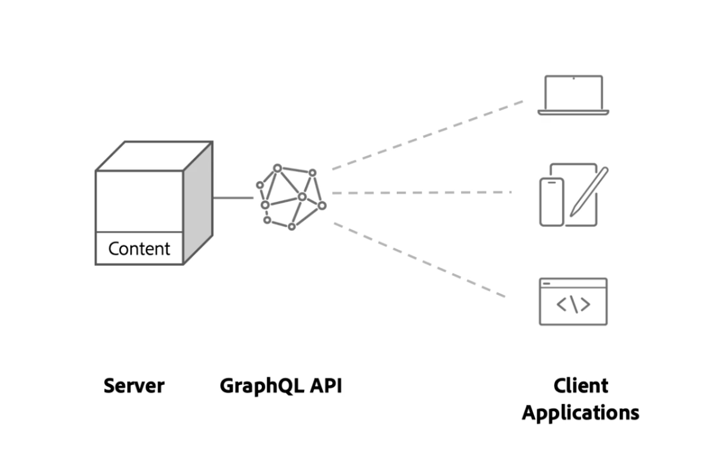

AEM GraphQL vs. AEM Content Services
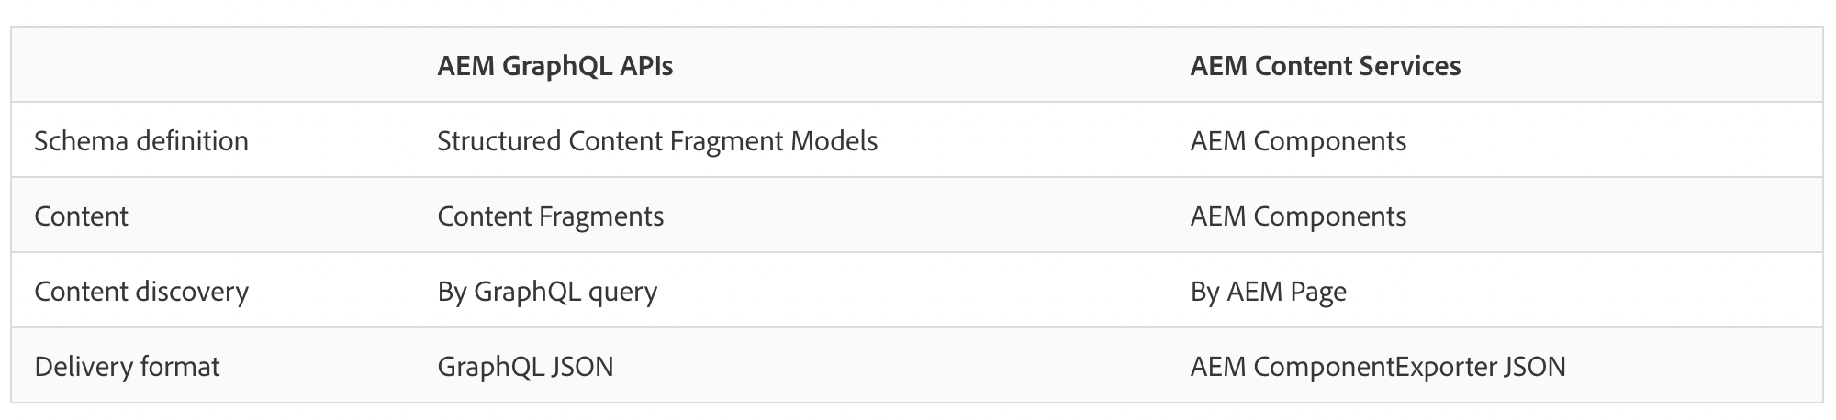

BFF
There is possibility to use Backend for Frontend (BFF) layer to serve as an intermediary between the frontend and the data sources, namely AEM GraphQL and microservices. The BFF layer will effectively combine data from these sources, presenting a unified and simplified interface to the frontend while abstracting the complexities of multiple data sources.

The two most important advantages of adopting this approach are:

Efficient Data Aggregation: The BFF layer allows us to aggregate data from multiple data sources, such as AEM GraphQL and microservices, into a single request. This minimizes the number of API calls made by the frontend, reducing network overhead and improving overall application performance. By fetching only the required data and composing it at the backend level, we optimize data transmission, resulting in faster load times and improved user experience.

Customization and Adaptability: The BFF pattern enables us to tailor data to the specific needs of the frontend. It serves as a single point of contact between the frontend and various data sources, providing the flexibility to preprocess, filter, or combine data as required. This customization capability allows us to adapt the API responses to meet frontend requirements without altering the underlying data services. Additionally, it shields the frontend from changes in the data sources, ensuring backward compatibility and smoother maintenance.

However, it is essential to be aware of the following potential challenges:

Increased Complexity: Introducing a BFF layer adds an additional architectural component that must be designed, implemented, and maintained. Managing this intermediary layer can introduce complexity to the overall system, potentially leading to increased development efforts and the need for additional resources. Proper documentation and adherence to best practices are vital to mitigate complexity-related issues.

Single Point of Failure: Since the BFF layer acts as a single source of data for the frontend, any failures or issues with this layer can directly impact the entire frontend application. Ensuring high availability, robust error handling, and fault tolerance mechanisms are crucial to mitigate the risk of a single point of failure. Monitoring and redundancy strategies should be in place to address potential downtime scenarios effectively.

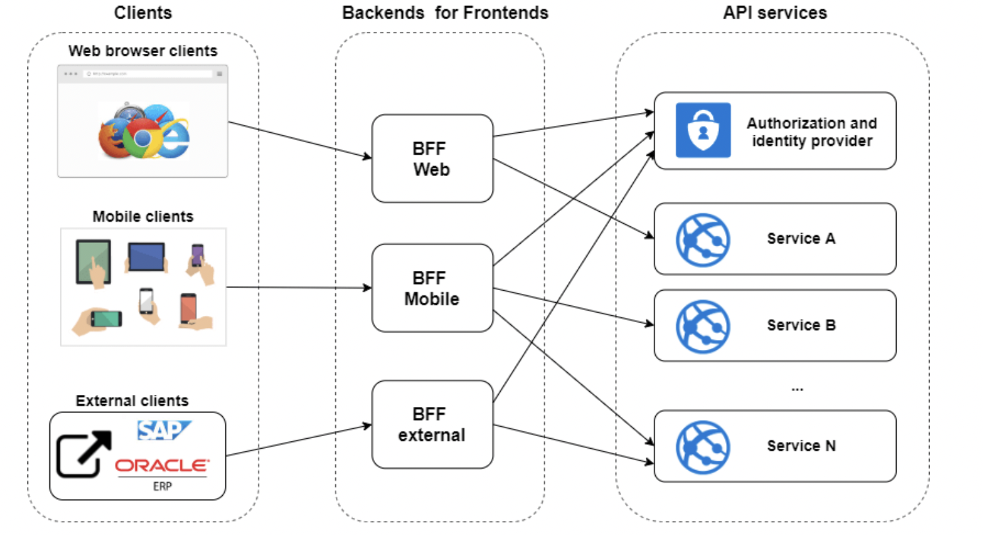
Source: https://dev.to/damikun/web-app-security-understanding-the-meaning-of-the-bff-pattern-i85

Conclusions
In this whitepaper, we explored the methods of combining technologies that pave the way for an enhanced digital experience—integrating Adobe Experience Manager (AEM) as a headless CMS with Micro Frontend architecture and microservices. By adopting this approach, organizations can unlock a variety of benefits, empower their development teams, and create seamless, future-proof digital experiences for their users.
In summary, the combined benefits of AEM, Micro Frontend s, and Microservices create a powerful architecture that enhances performance, scalability, and flexibility while fostering collaboration and innovation. This modern approach ensures organizations can deliver exceptional digital experiences to their users, stay competitive, and adapt to future challenges in the rapidly evolving digital landscape.

Resources
List of resources and references link related to the topic.
https://www.mindinventory.com/blog/micro-frontend-architecture/
https://www.simform.com/blog/micro-frontend-architecture/
https://www.sitepoint.com/a-beginners-guide-to-the-micro-front-end-architecture/
https://jscrambler.com/blog/web-workers-and-the-threads-that-bind-us

BFF:
https://dev.to/damikun/web-app-security-understanding-the-meaning-of-the-bff-pattern-i85

Mono Repo:
https://monorepo.tools/
https://lerna.js.org/

